What’s Happening In the U.S.
August 4, 2020
Kanae Haneishi, Ed.D.

While U.S.A is struggling to lower the number of the COVID-19 cases around the country, schools and sport organizations have been making tough decisions for back-to-school as well as sport participations. As the situation changes every day, I will try my best to explain what is happening in the US now.

The academic school year in the U.S. starts around end of August to beginning of September. As school administrators and teachers are preparing for re-opening the schools, the organizations like SHAPE America and Kaiser Permanente provide helpful resources and guidelines along with governmental organizations like CDC. Social distancing, wearing mask, washing hands frequently, and sanitizing places are the main focused points for preventing COVID-19. Some schools are considering reducing the Physical Education class time and the recess time, however sports/health organizations are strongly opposing for the ideas. Here is one of the examples.

While schools and sport organizations in some regions continue planning for re-“opening,” many regions seem to remain or go back to the lock-out mode (i.e., virtual school and essential workers only). Professionals in Physical Education and sports will be playing important roles for the up-coming months, especially for those who has to stay home. Many professionals have been offering free virtual fitness sessions for the kids and youth.

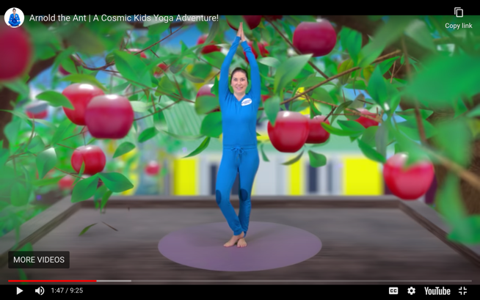

Mental health during pandemic has been also a major concern in this country. Many of parents have been dealing with home-schooling for their kids while working from home. Many kids have been isolated because they cannot play with their friends. Many of their favorite sport activities have been canceled. SHAPE America has been providing multiple “self-care” resources. Boys and Girls Clubs of America offers the important points on kids’ mental health during COVID-19.

Additionally, game-teaching researchers, physical education teachers, and sport coaches have been considering how this COVID-19 has been influencing on games teaching. It seems like that focusing on target games has been a mainstream. The students can enjoy the games while maintaining social distancing or even participating virtually. Students who are required the social distancing as well as who are learning virtually still love the challenges and the excitement that games can bring. Many of the target games can be played with simple equipment or something that the students can find at home. It is important for us, as the game-centered exsperts, to continue providing useful tools and knowledge for teachers and coaches so the learners (i.e., students and players) can still enjoy the game playing during this pandemic.

